Lab 4

Pdf 194 and book page number 176

Task 1

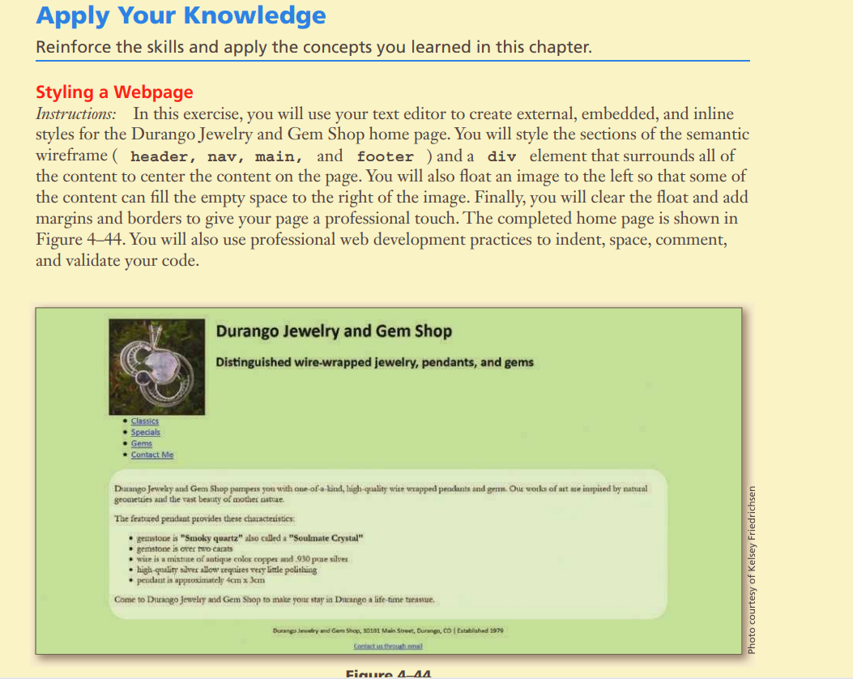

Task 2

